1. **Managing Disk Quota**
2. Allow disk quota
3. Deny disk space for certain user if he exceeds his quota limit

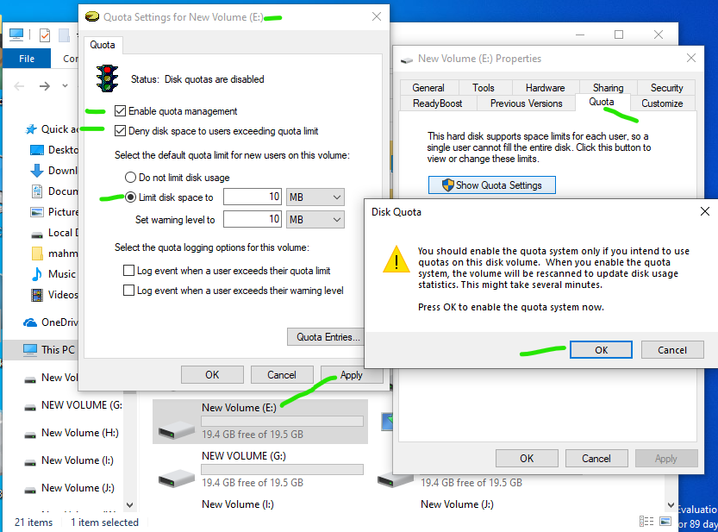

**Answer:**

* + Disk management 🡪 R-click on partition🡪Properties🡪 Quota
  + Quota tab 🡪 red color 🡪 enable Quota management 🡪 apply 🡪 Yellow color " Status: Rebuilding Disk Quota information "🡪then Green Color" disk quota is **active**".
  + Check "Deny Disk space to users exceeding Quota limit" 🡪 apply
  + Quota Entries 🡪 select the user entry 🡪 specify user limits on this partition.

Make user Doaa not able to use more than 2GB on drive E:

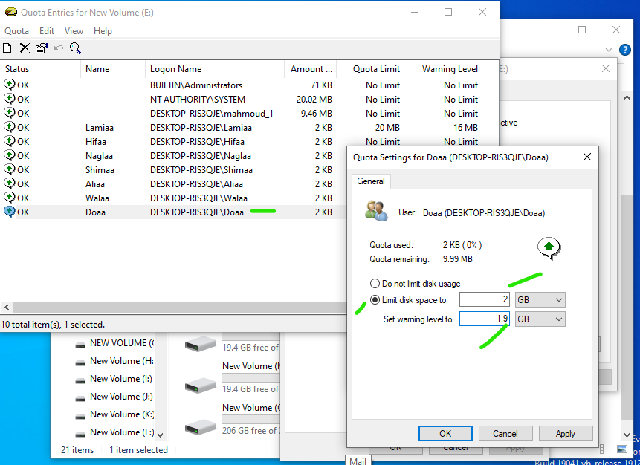

Make user Lamiaa not able to use more than 20MB on drive E: with warning 16MB

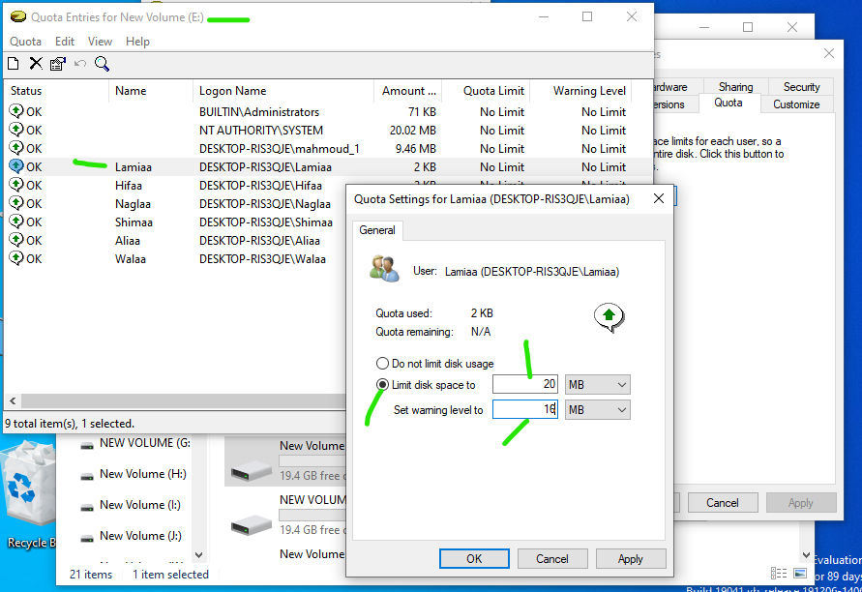

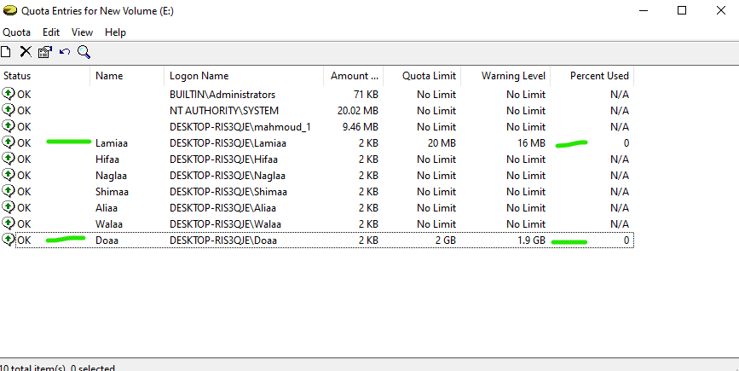

**2.Managing data compression**

* 1. Compress Files and Folders

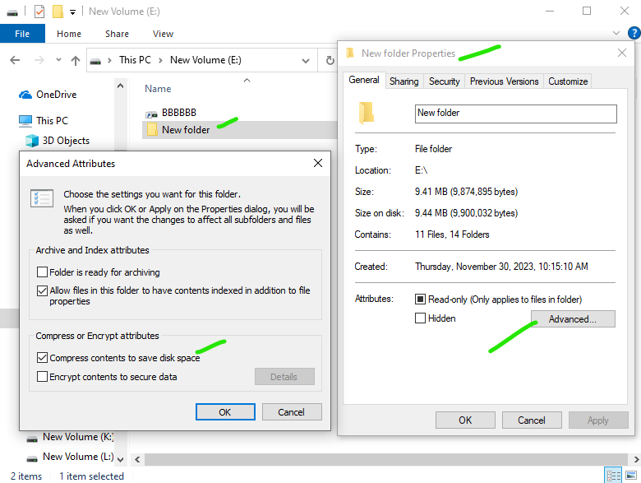

* 1. View compressed files in different color

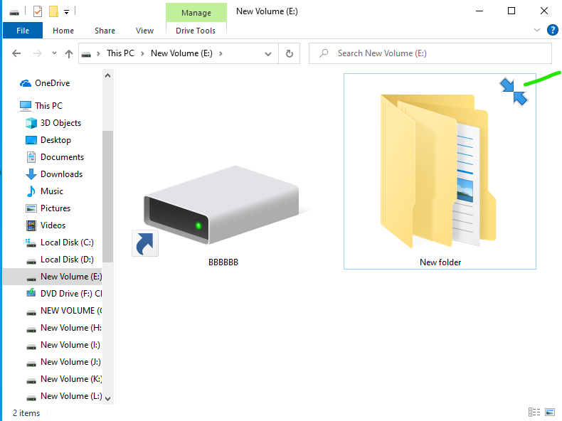

* 1. Copying compressed files (check what's happened.)

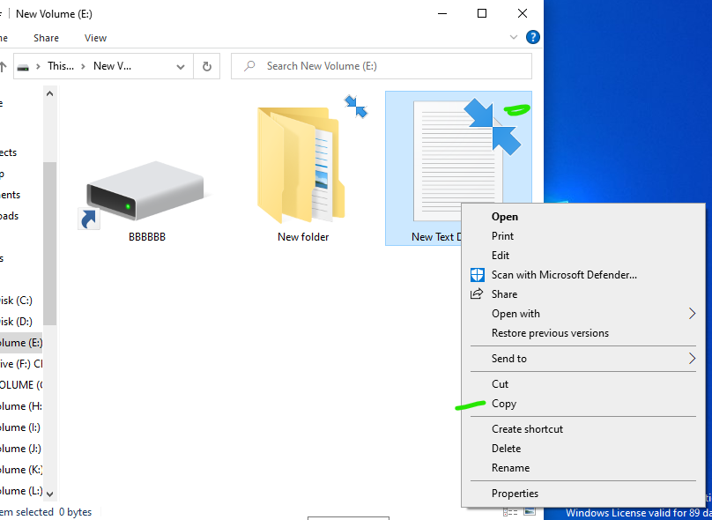

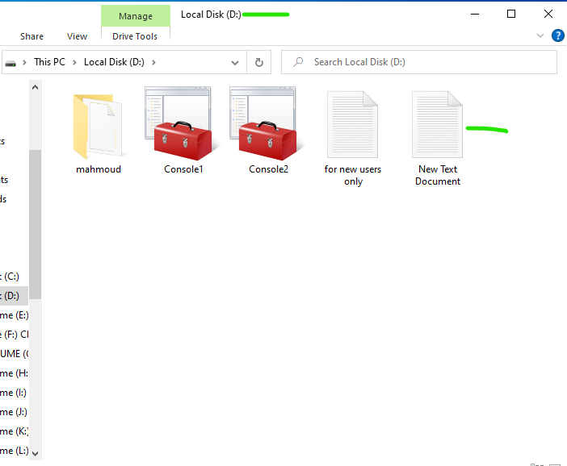

* 1. Moving compressed files (check what's happened.)

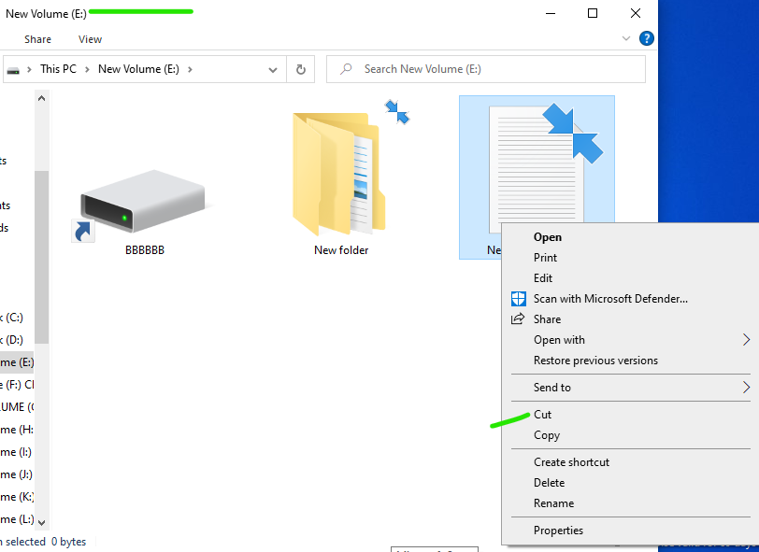

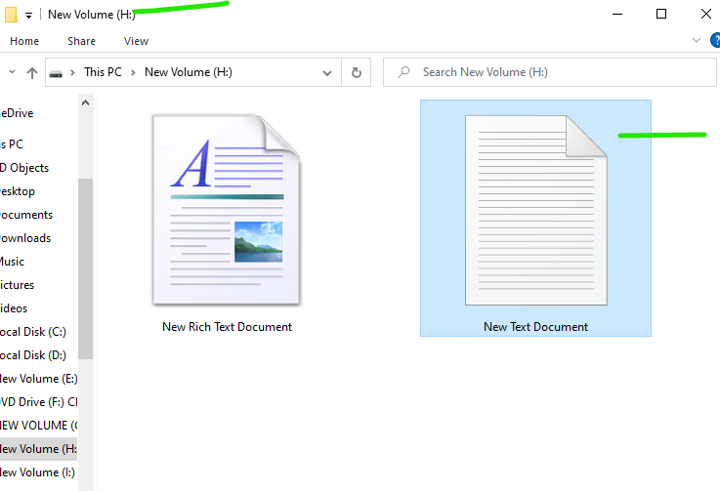

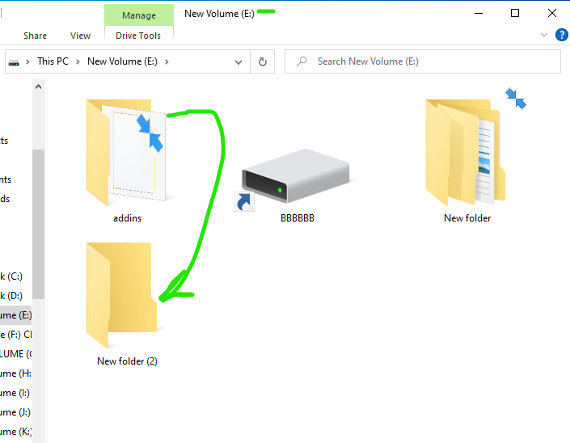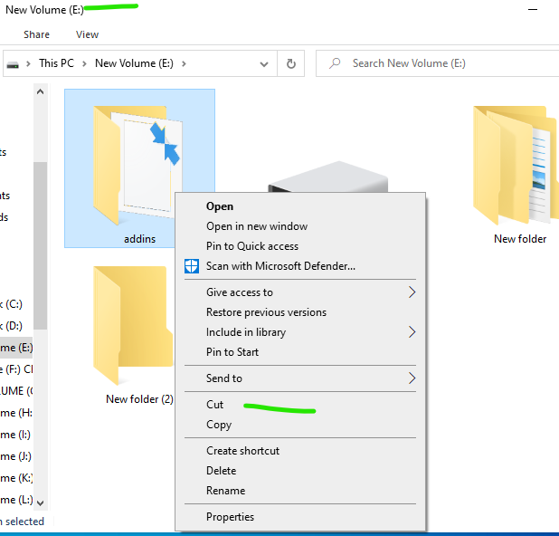

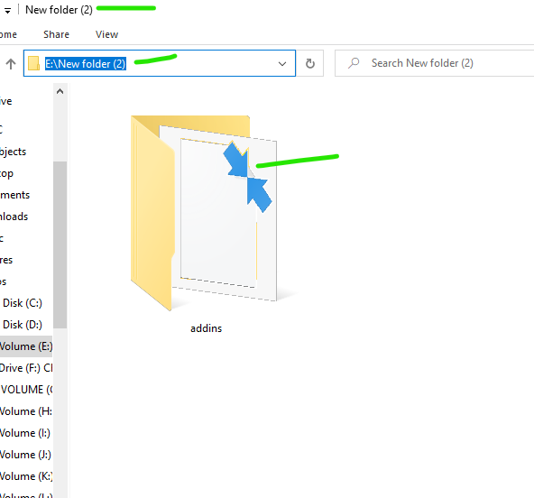

**Answer:**

1. Only with NTFS files and folders
2. R-click on any File 🡪 Properties 🡪 General tab 🡪 Advanced 🡪 Compress file 🡪 apply 🡪 **Size on disk** lower than **Size**
3. File name Color is BLUE
4. Copy the file to another Folder on the same partition 🡪 the file will be uncompressed
5. *Copy* or *Cut* the file to another folder on another partition 🡪 the file will be uncompressed "**inherit** from parent folder"
6. *Cut* the file to another folder on same partition 🡪 the fill is compressed "**retain**".

**3.Managing NTFS encryption**

1. Encrypt files

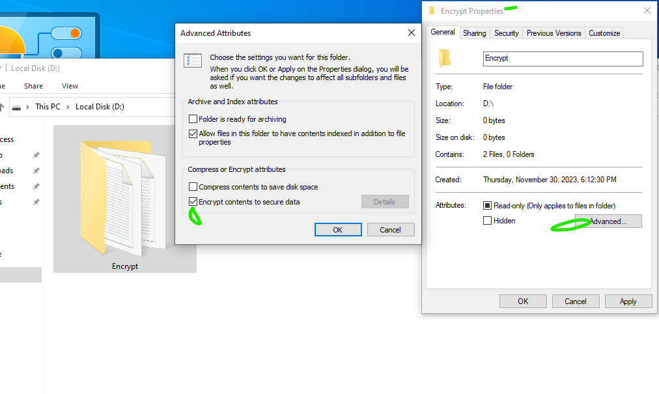

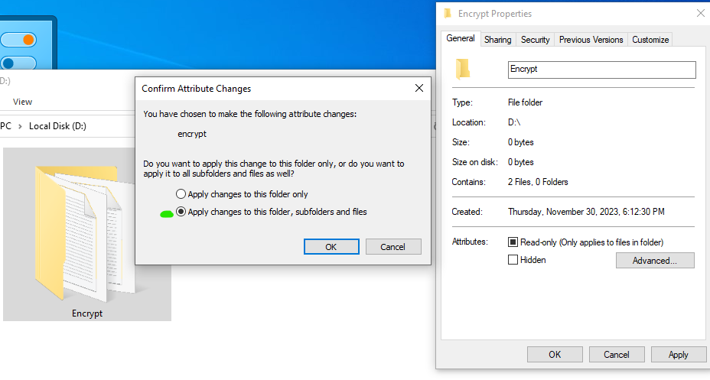

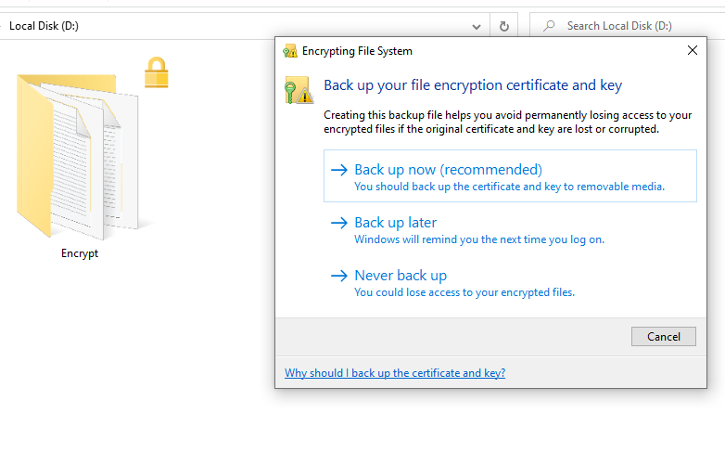

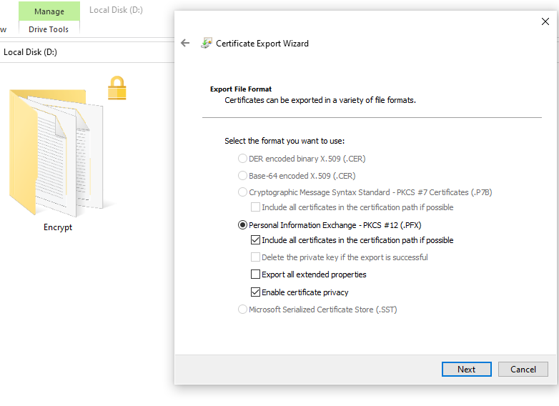

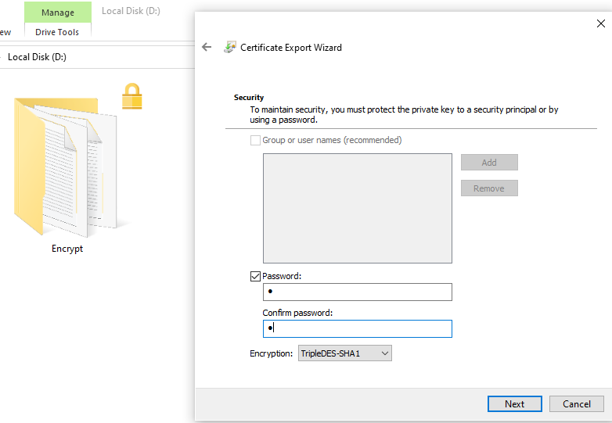

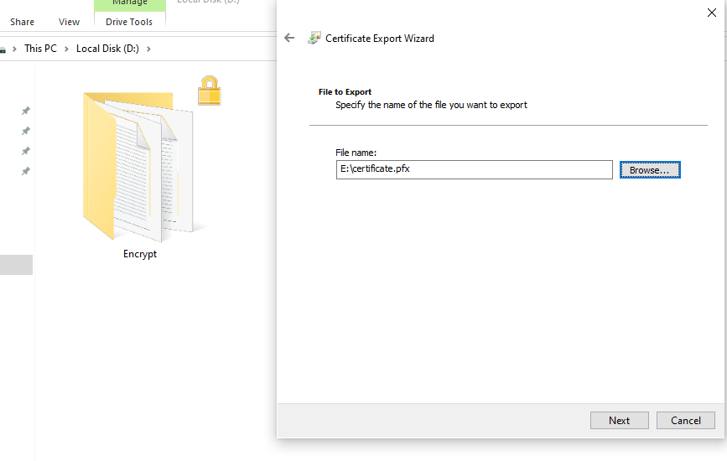

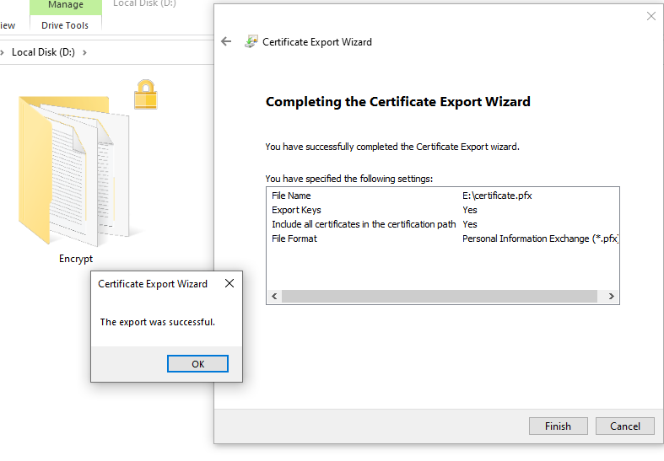

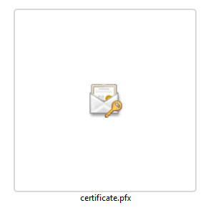

Or

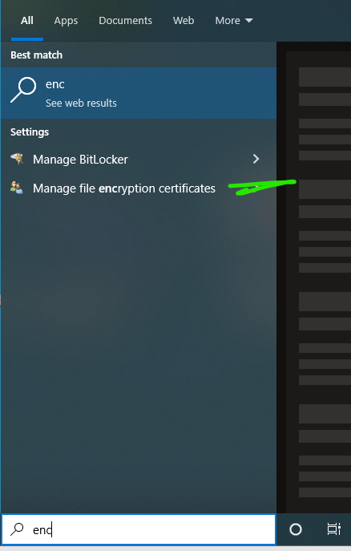

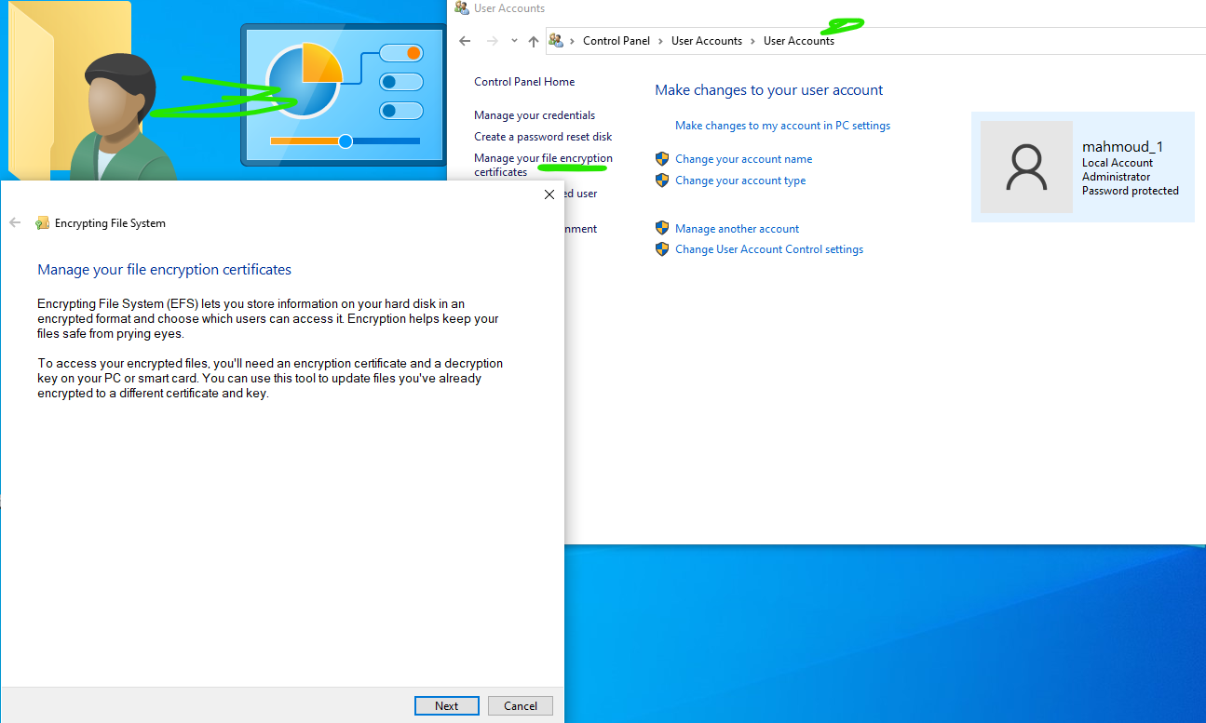

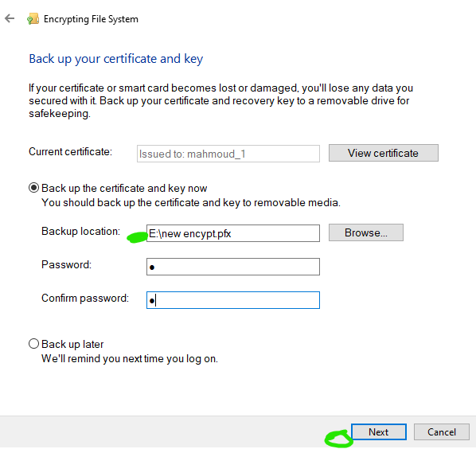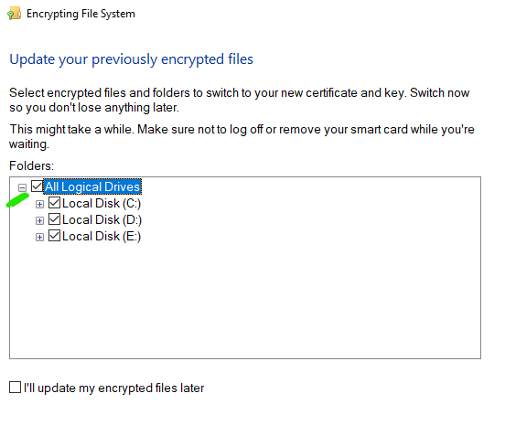

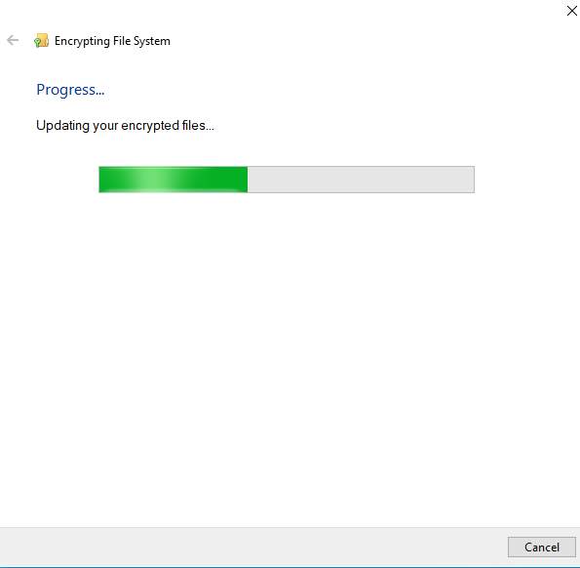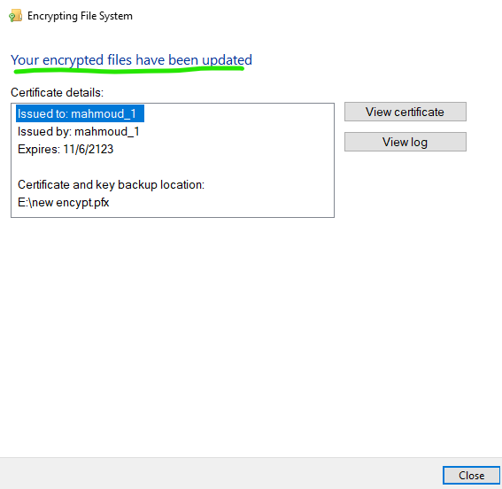

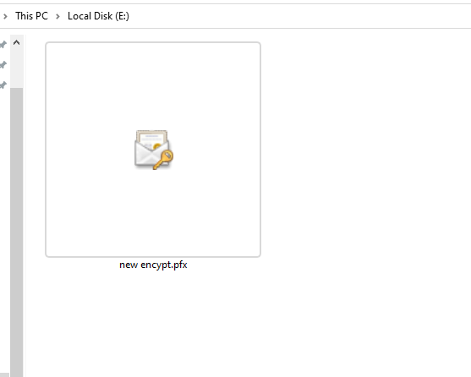

* 1. Test encrypted files

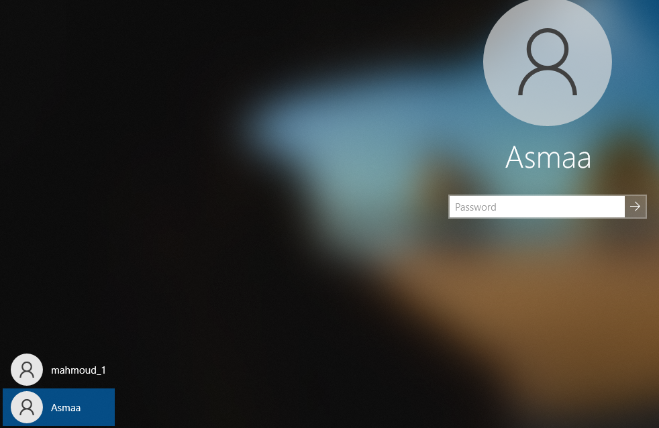

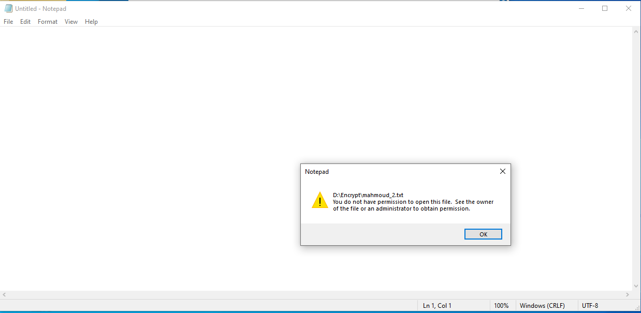

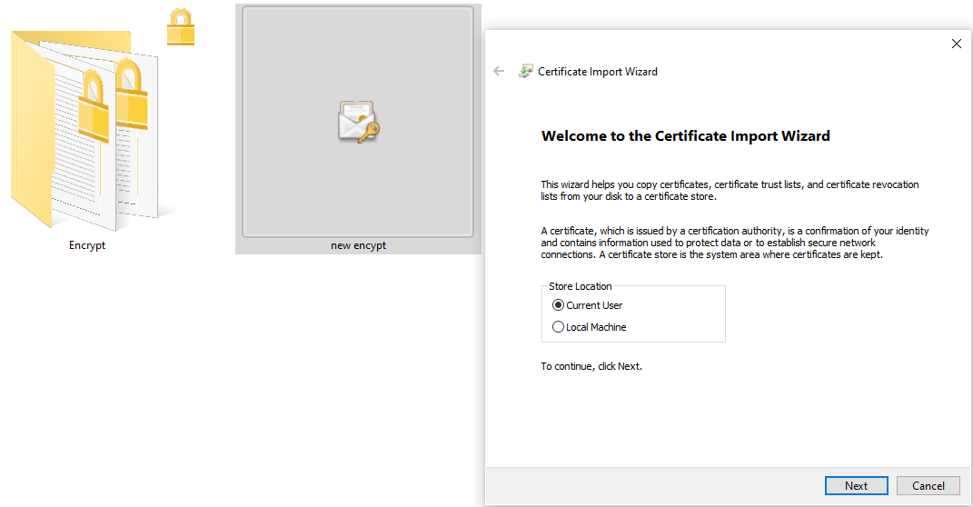

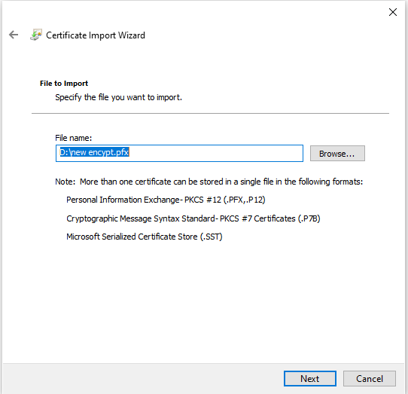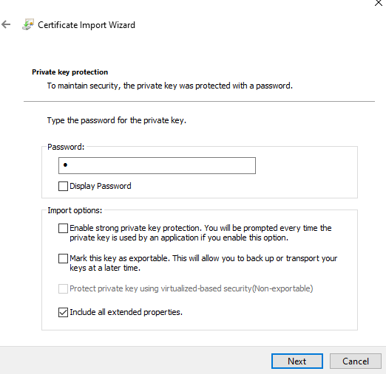

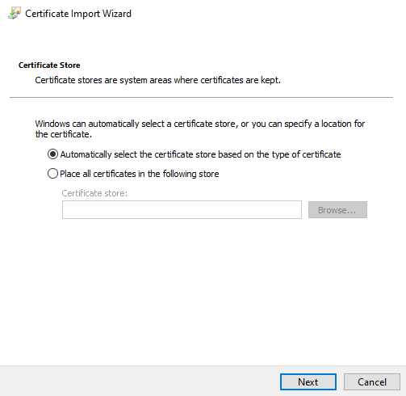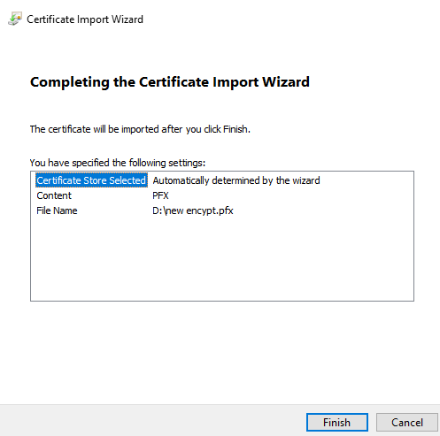

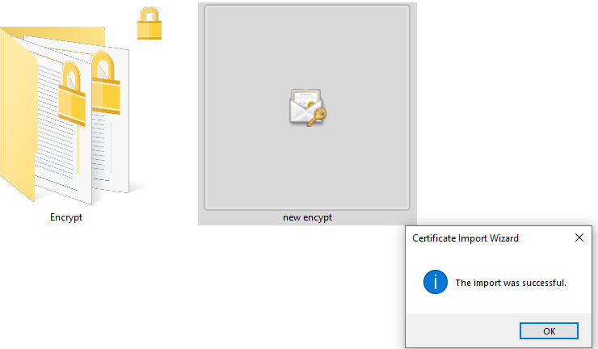

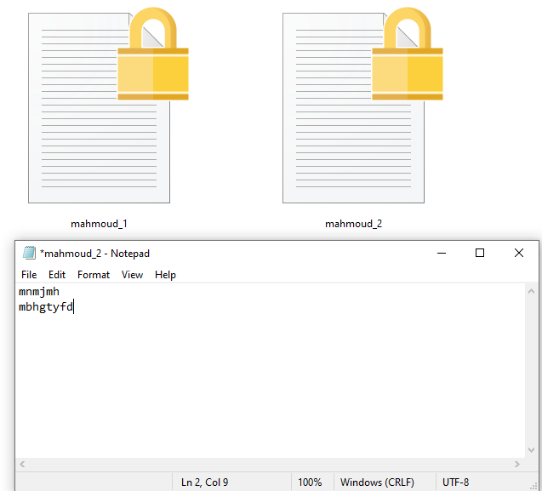

* 1. Difference between **change password (from Control Panel)** and **reset password** **(from MMC)** in dealing with your encrypted files

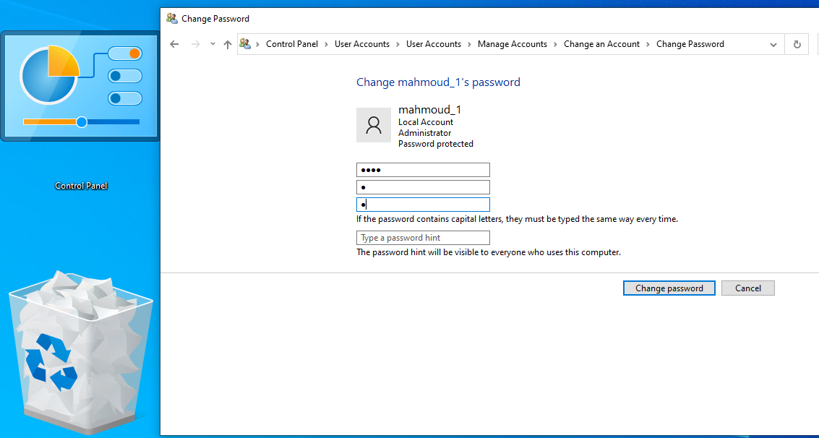

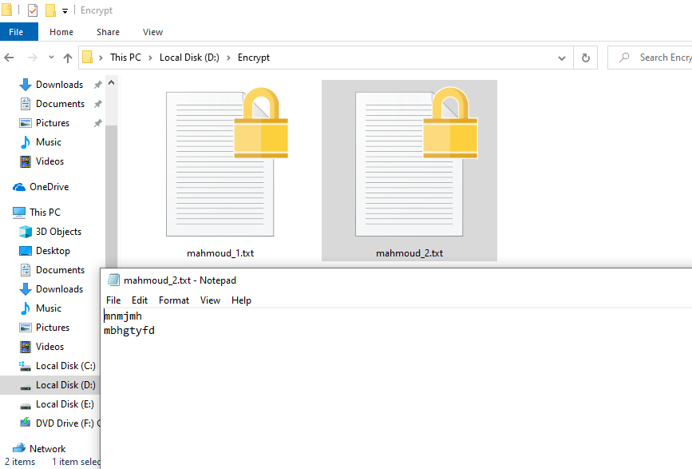

Set password

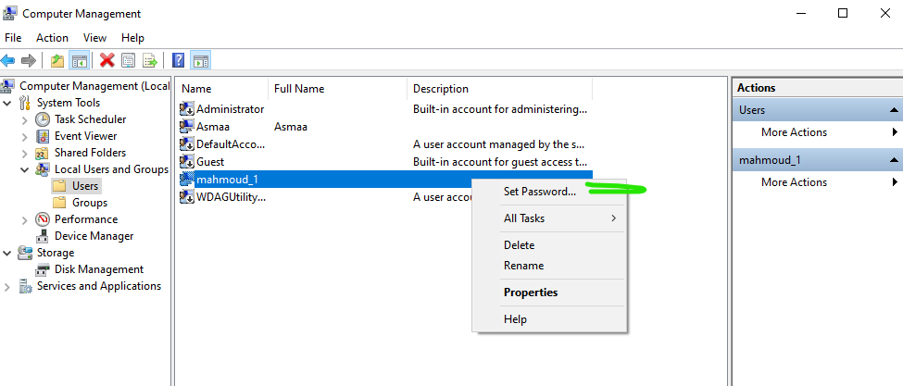

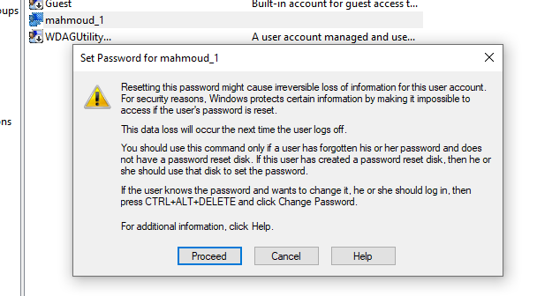

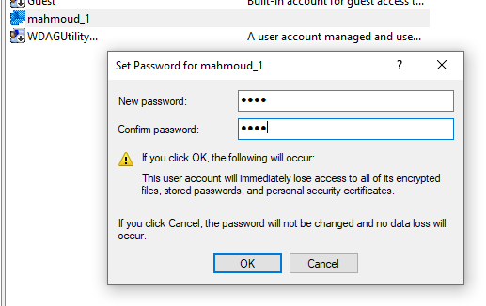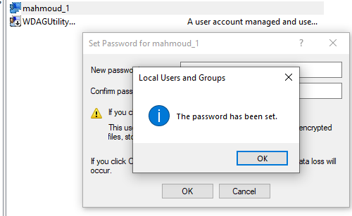

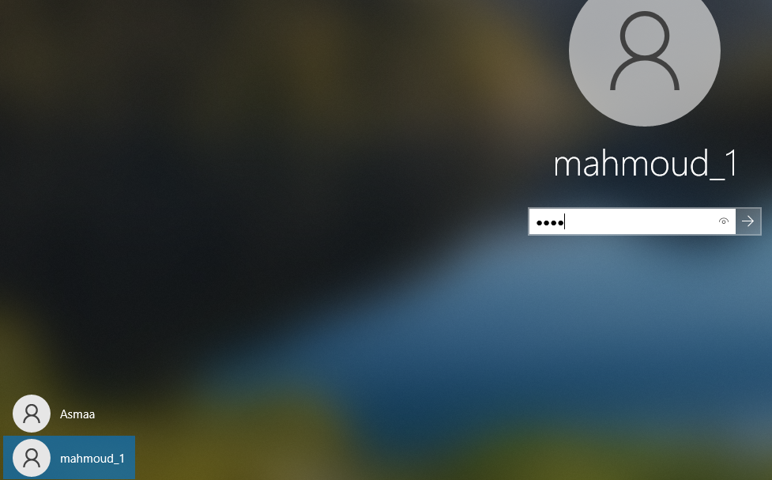

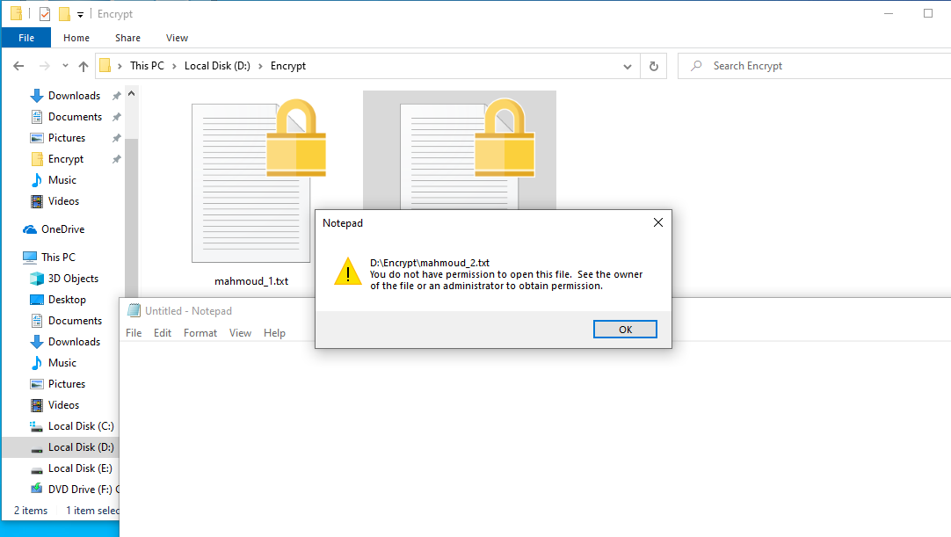

1. Add users who can view transparently your encrypted files (be sure that you have at least another account, and this account has encrypted any file(s) before).

**Answer:**

* 1. Only with NTFS files and folders
  2. R-click on any File 🡪 Properties 🡪 General tab 🡪 Advanced 🡪 Encrypt file
  3. File icon locked in yellow locker.
  4. keys used in Encryption based on
     1. SID
     2. Password
  5. Changing Password effect:
     1. Change user account's password using control Panel 🡪 user open his encrypted files ☺
     2. Change user account's password using MMC 🡪 user can't open his encrypted files ☹
  6. Changing SID effect:
     1. Delete user and create another user with the ***same*** name 🡪 user can't open the encrypted files ☹

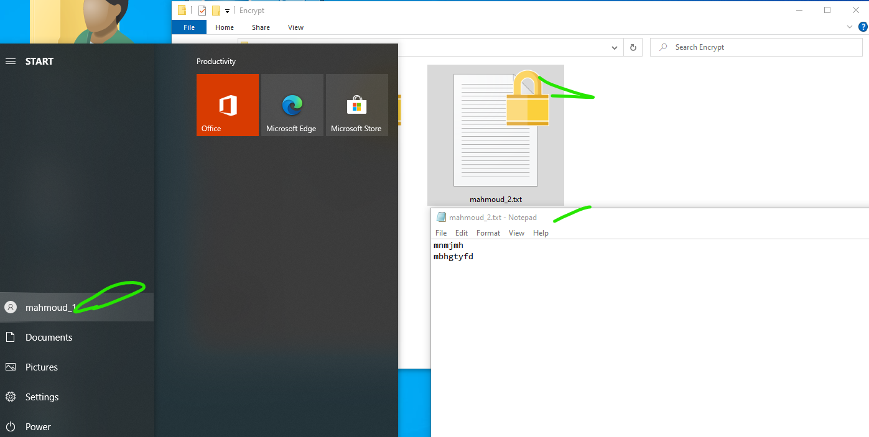

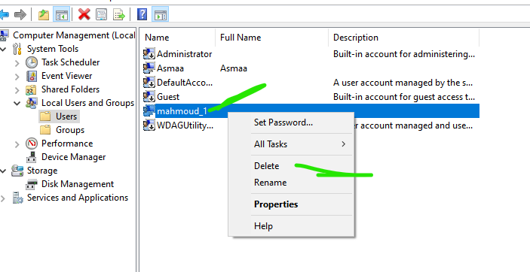

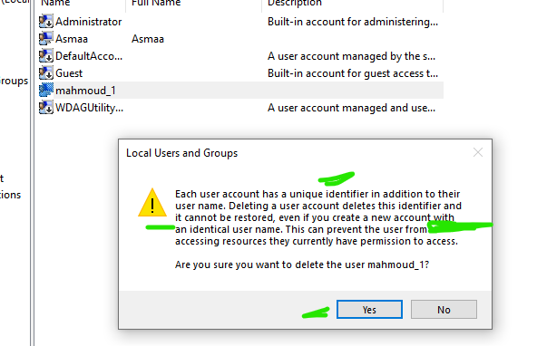

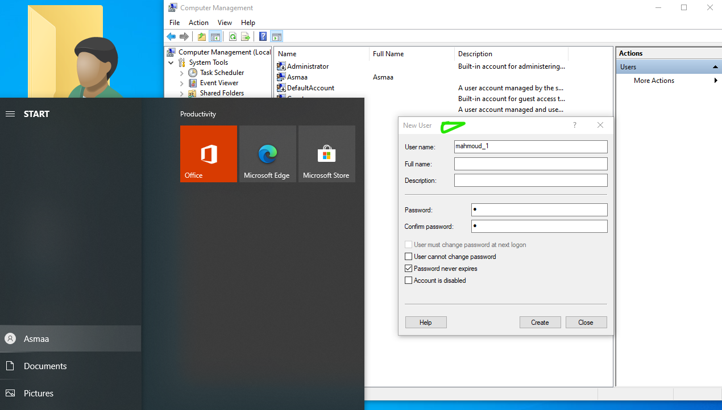

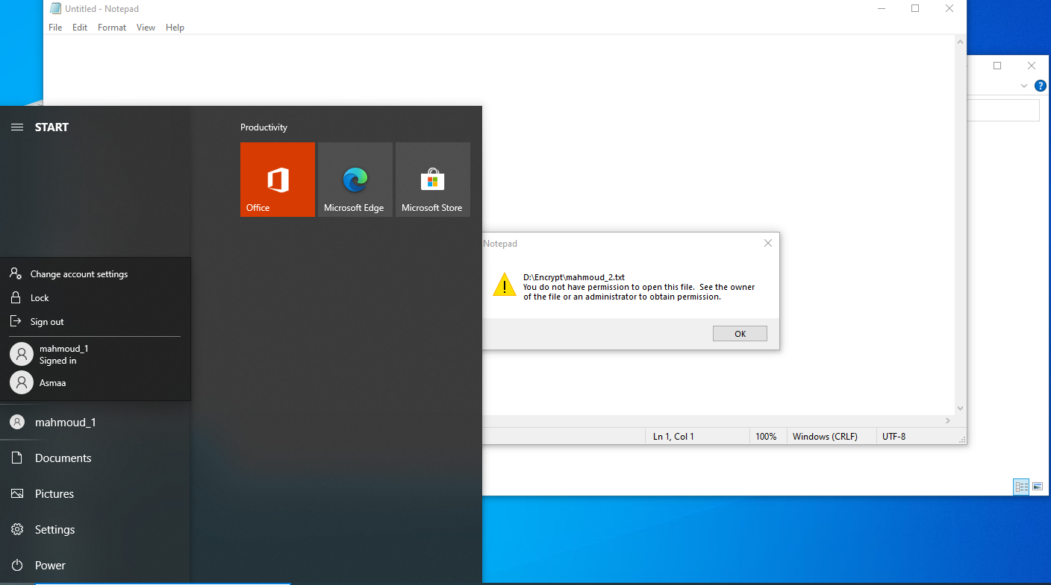

1. Move encrypted files between folders and partitions

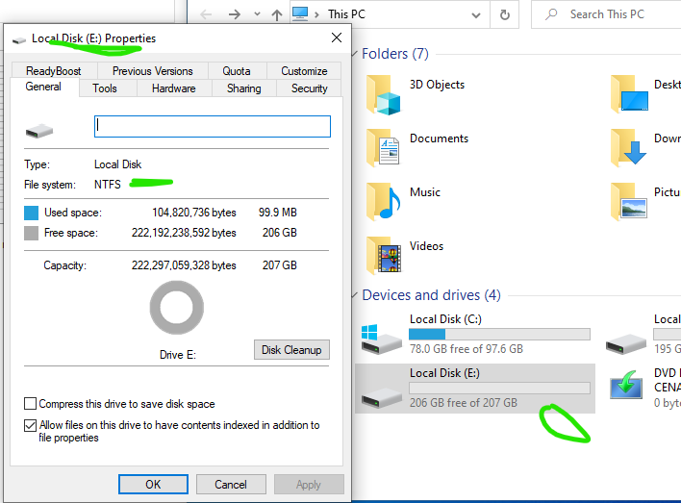

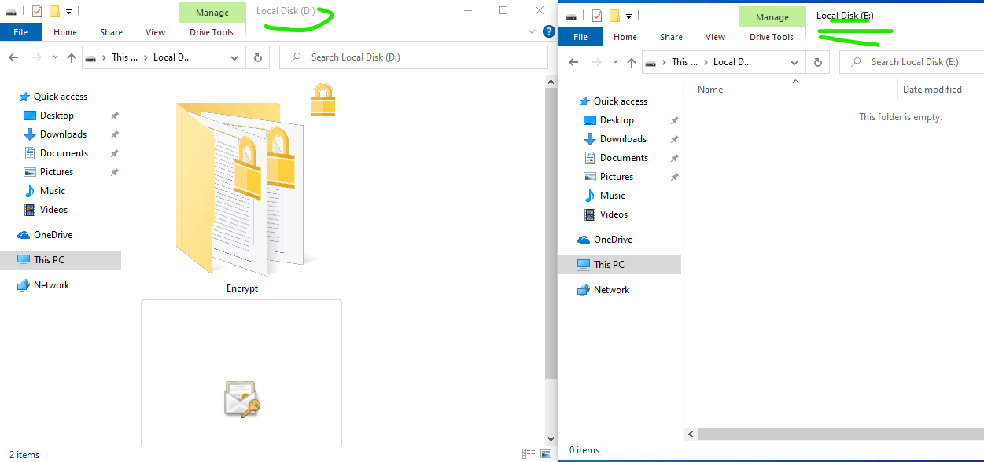

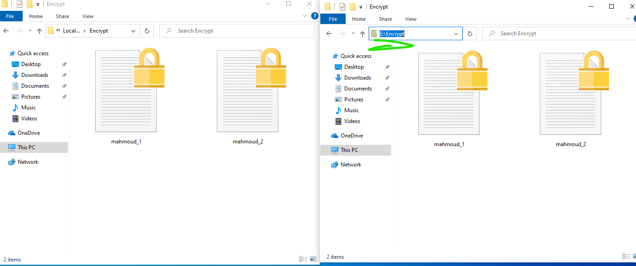

**FAT 32**

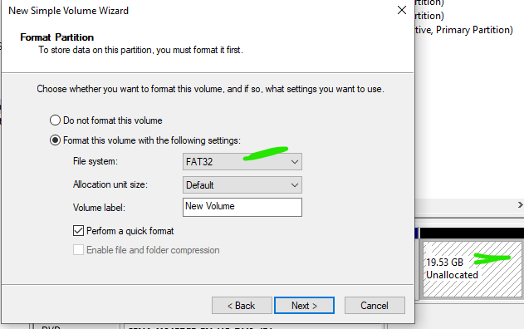

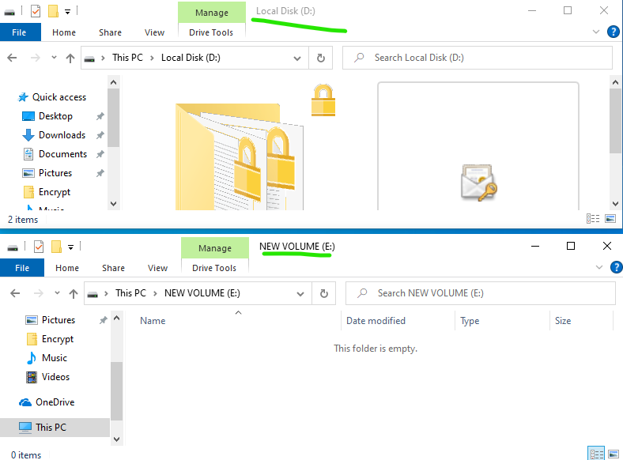

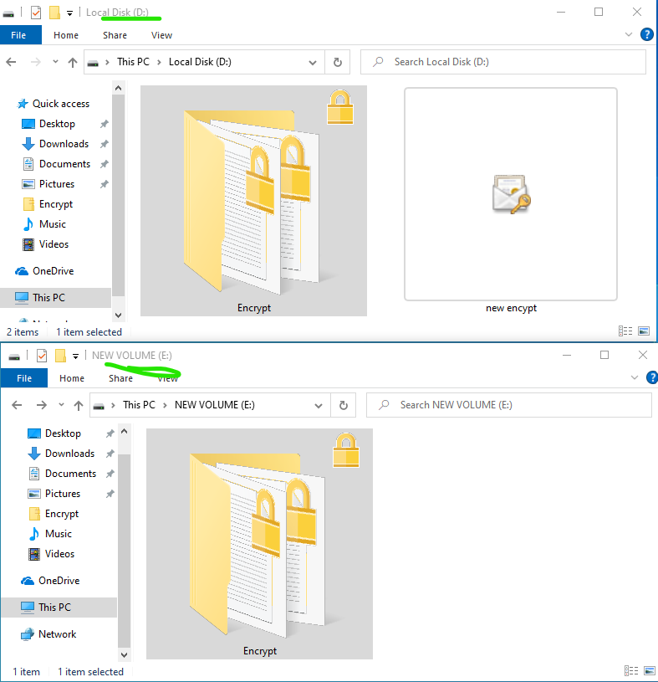

**Answer:**

* 1. *Copy* or *Cut* to NTFS partition did not effect on encrypted files ☺
  2. *Copy* or *Cut* to FAT32 partition decrypt files ☹
* Walaa encrypt her folder and give key to doaa to access her folder

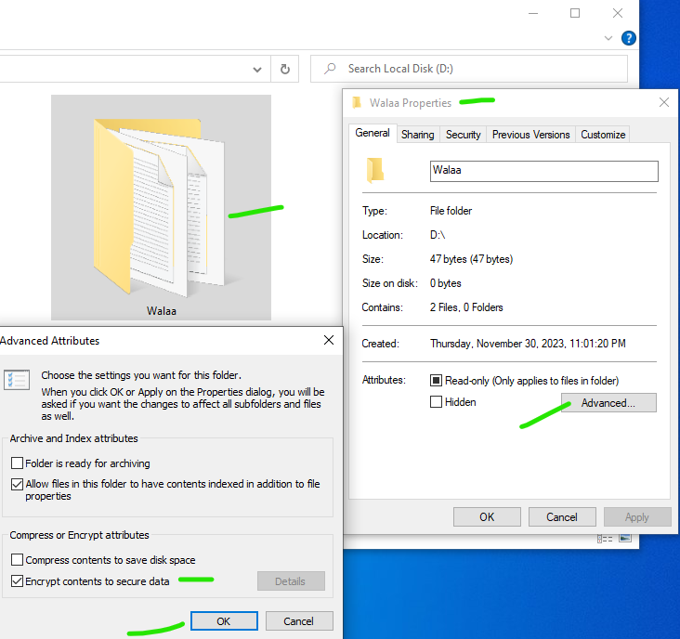

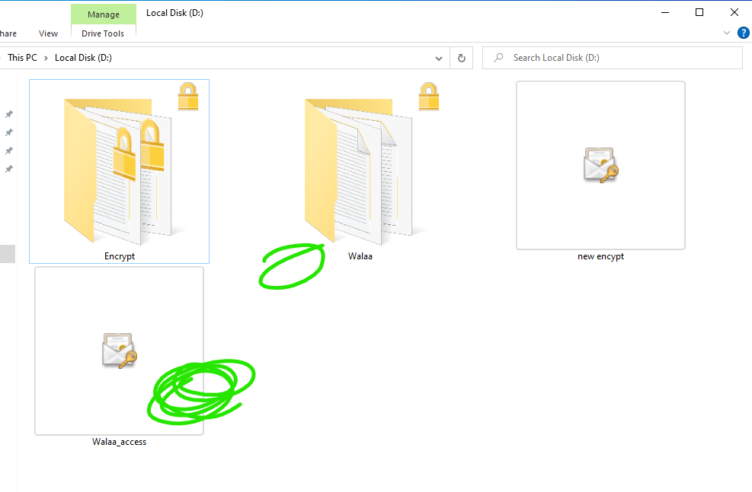

* The administrator reset walla password .. see if walaa can access her folder without the key

**4. page file:**

Move page file from root partition to partition D: .

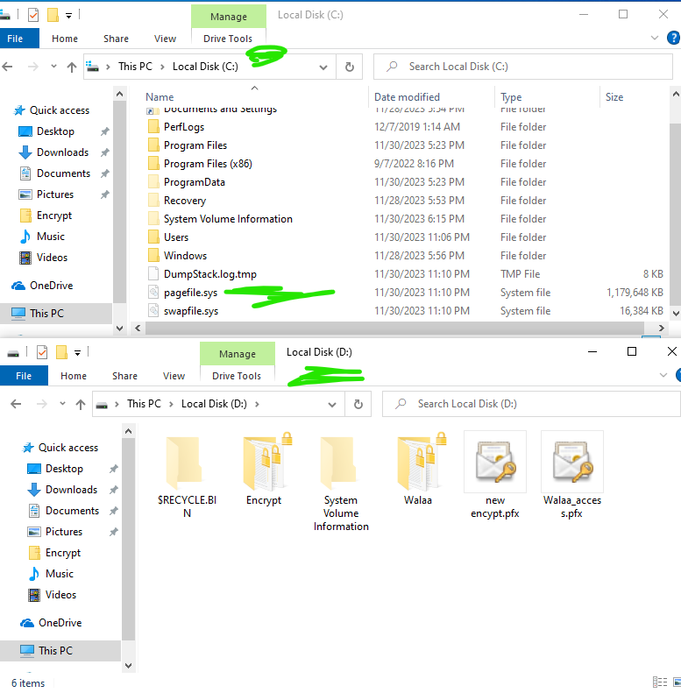

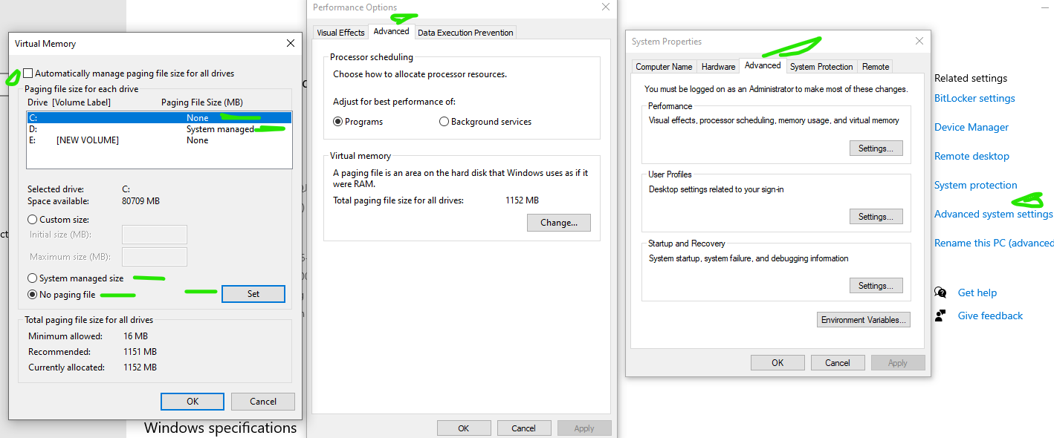

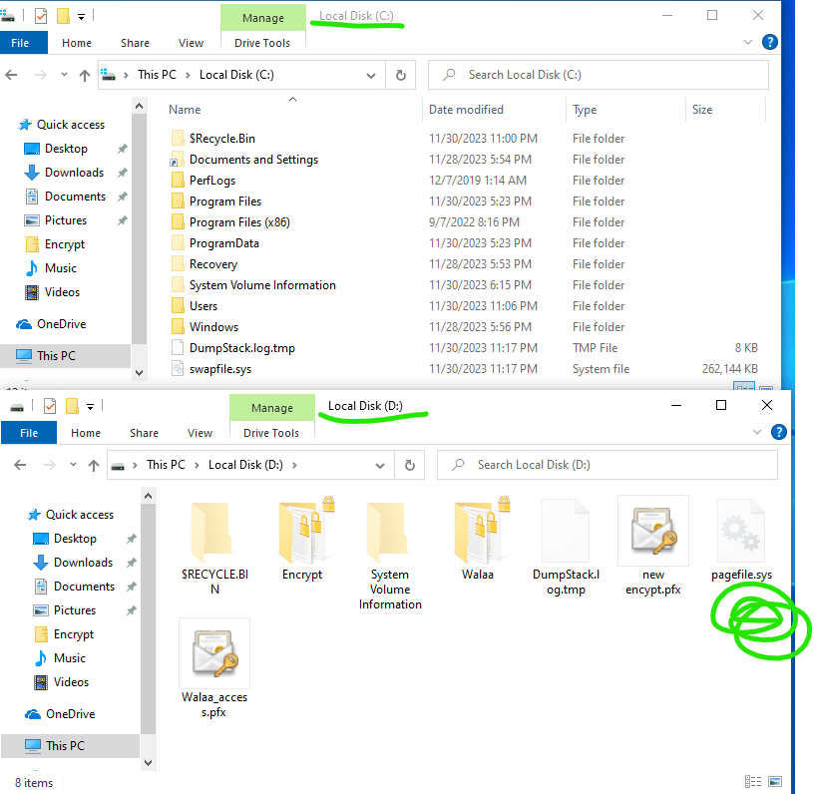

**5.Group policy:**

A. Account & Password policy:

run🡪cmd🡪Ctrl+Alt+Enter🡪yes🡪gpedit🡪Local security policy

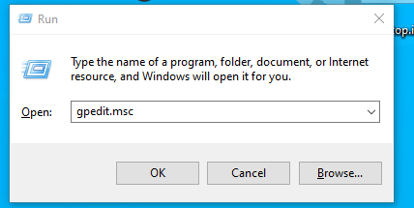

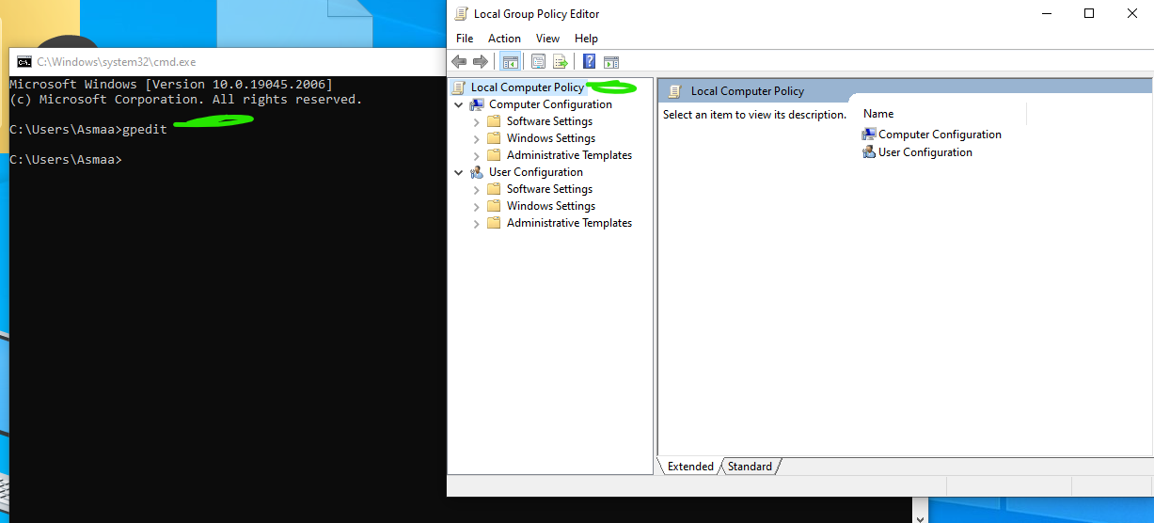

Computer Configuration🡪Windows Settings🡪Security Settings 🡪

Account policies🡪password policy

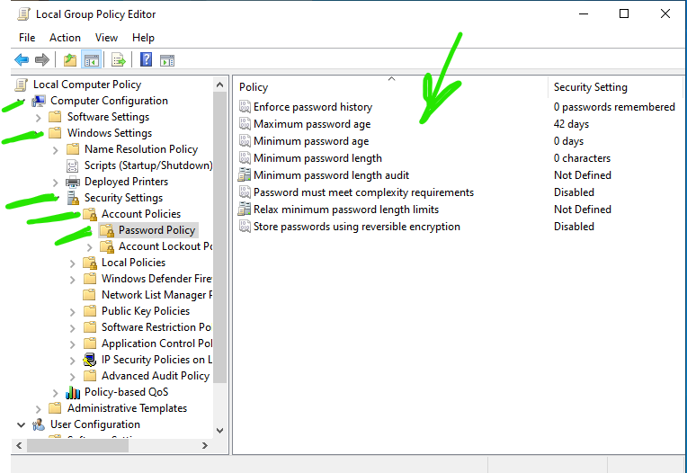

1. Account lockout policy:

run🡪cmd🡪Ctrl+Alt+Enter🡪yes🡪gpedit🡪Local security policy

Computer Configuration🡪Windows Settings🡪Security Settings 🡪

Account policies🡪Account lockout policy

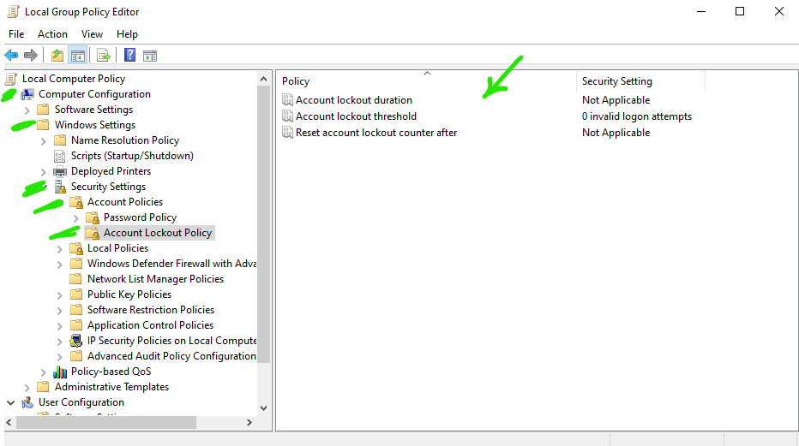

* Make user Asmaa the only one who can shutdown the PC

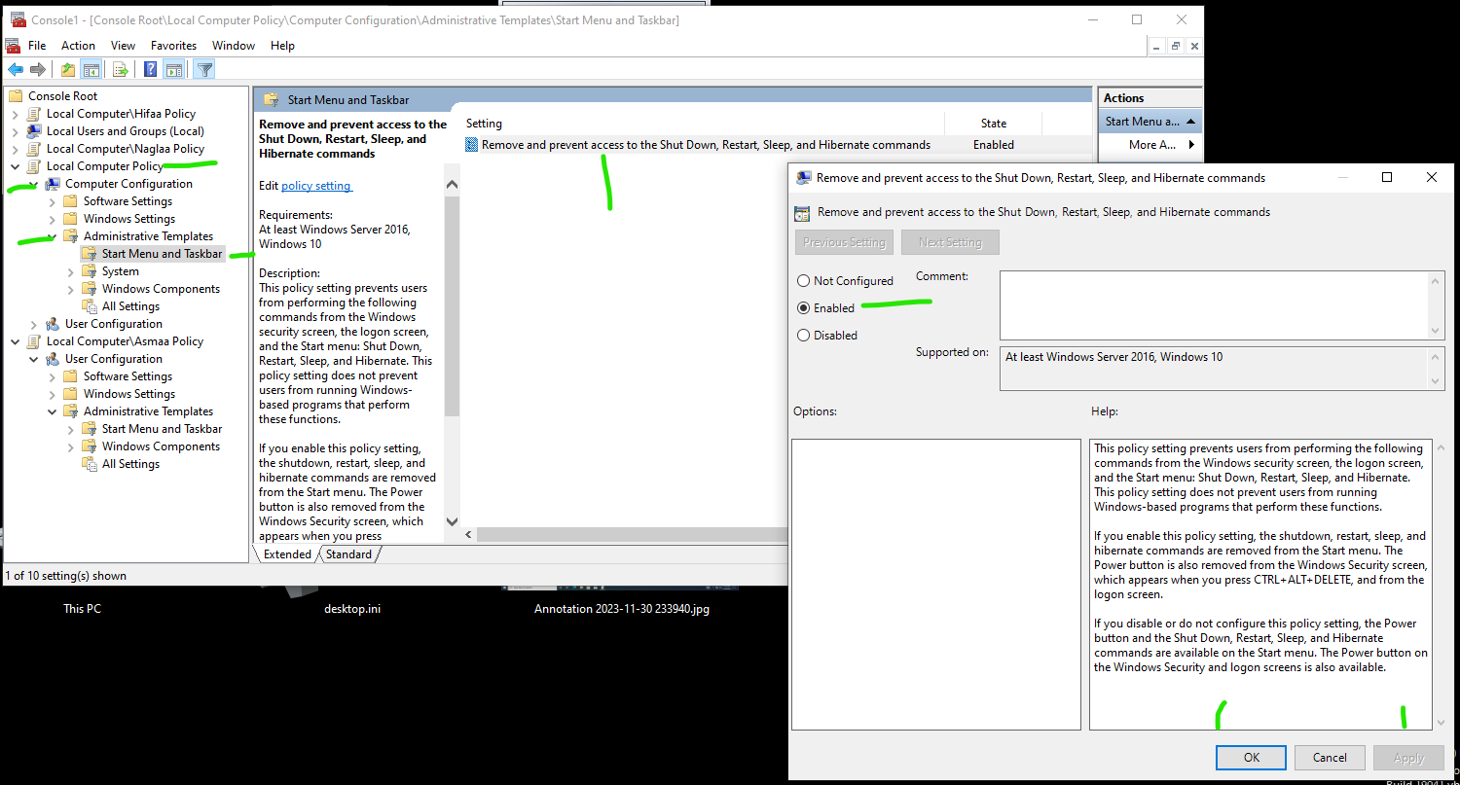

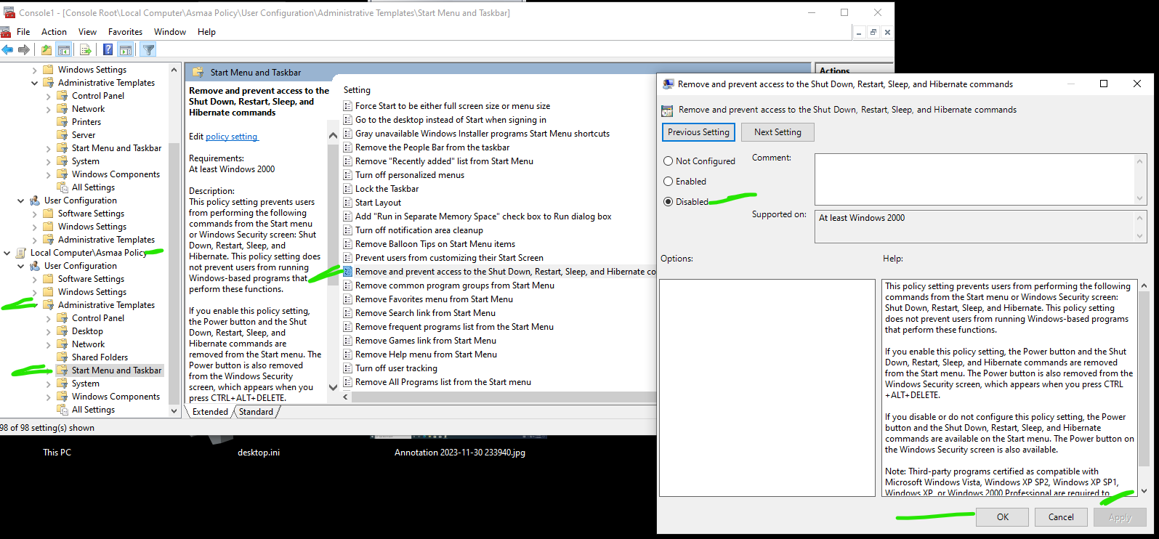

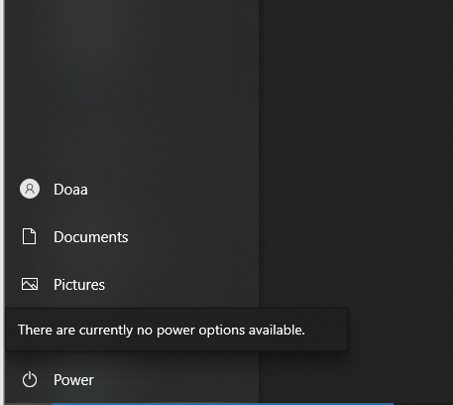



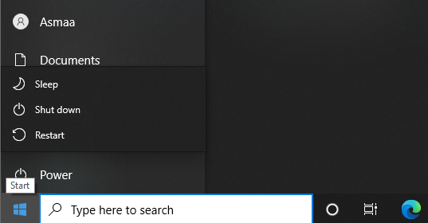



* Make the password must be complexed for all users

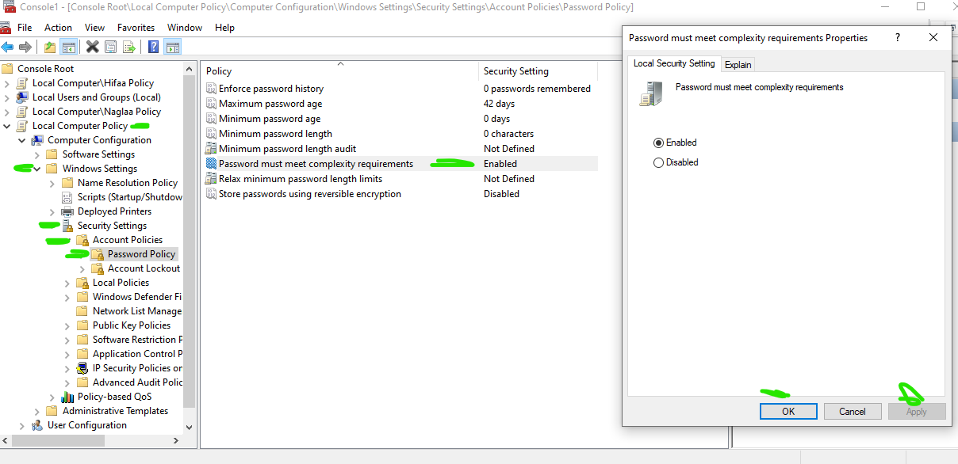

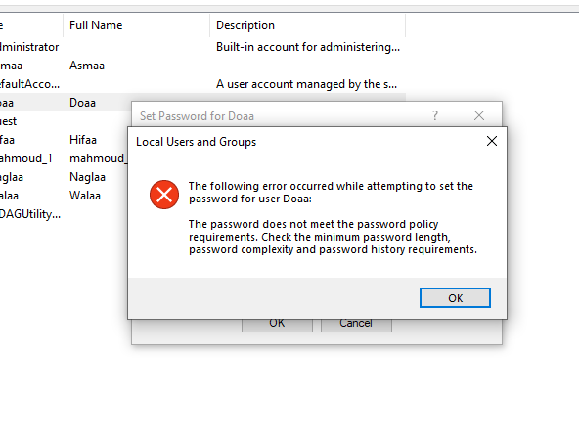

* If the user failed to enter the correct account password in 5 minutes for three times , the account will be disabled for one hour.

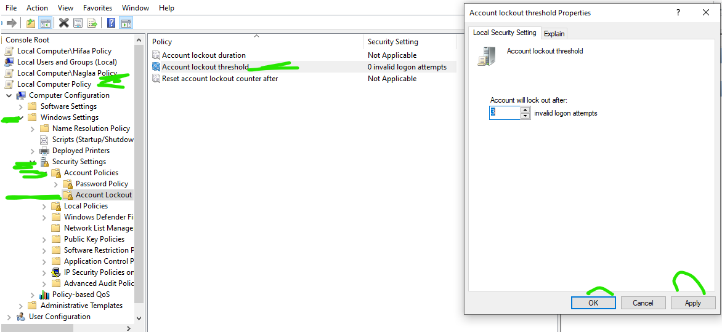

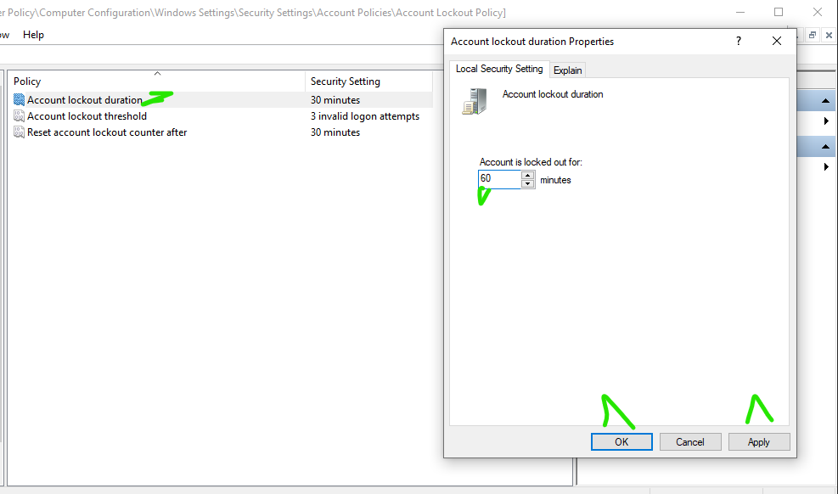

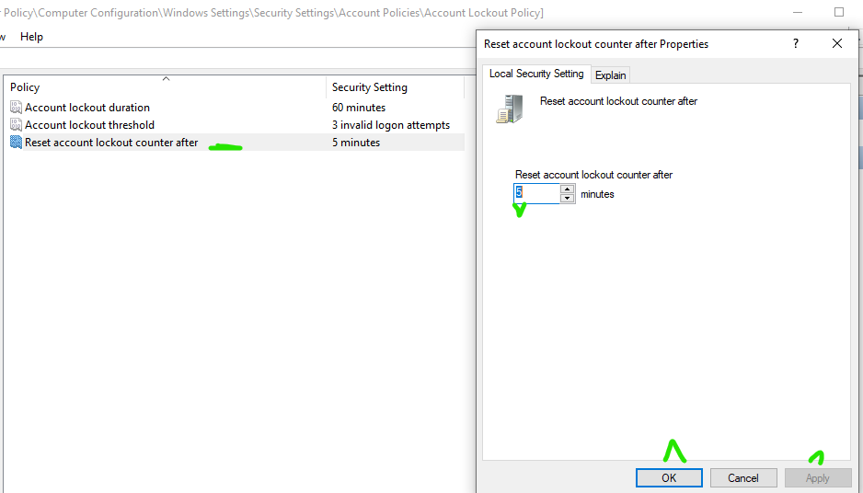

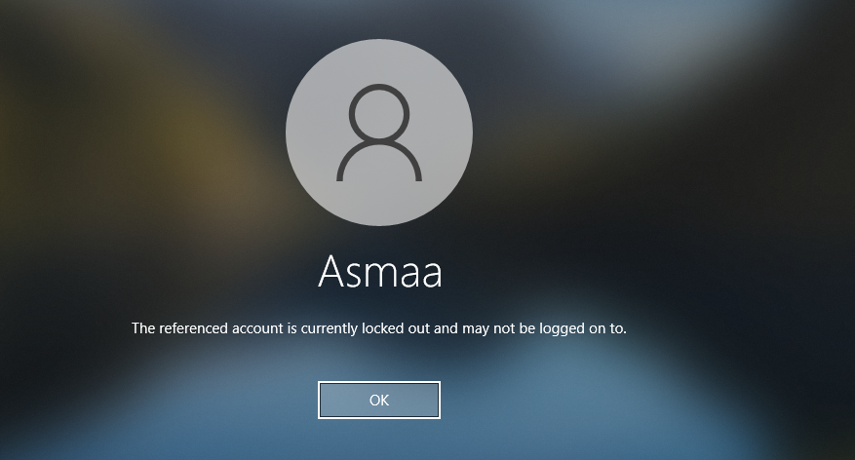

* User Asmaa can’t use flash memory.

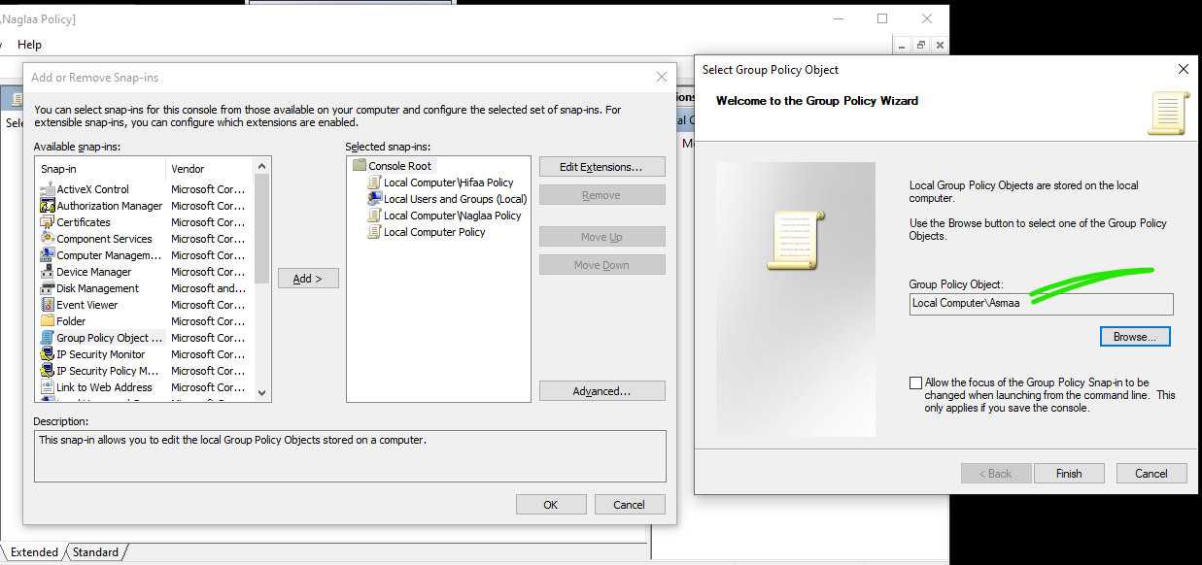

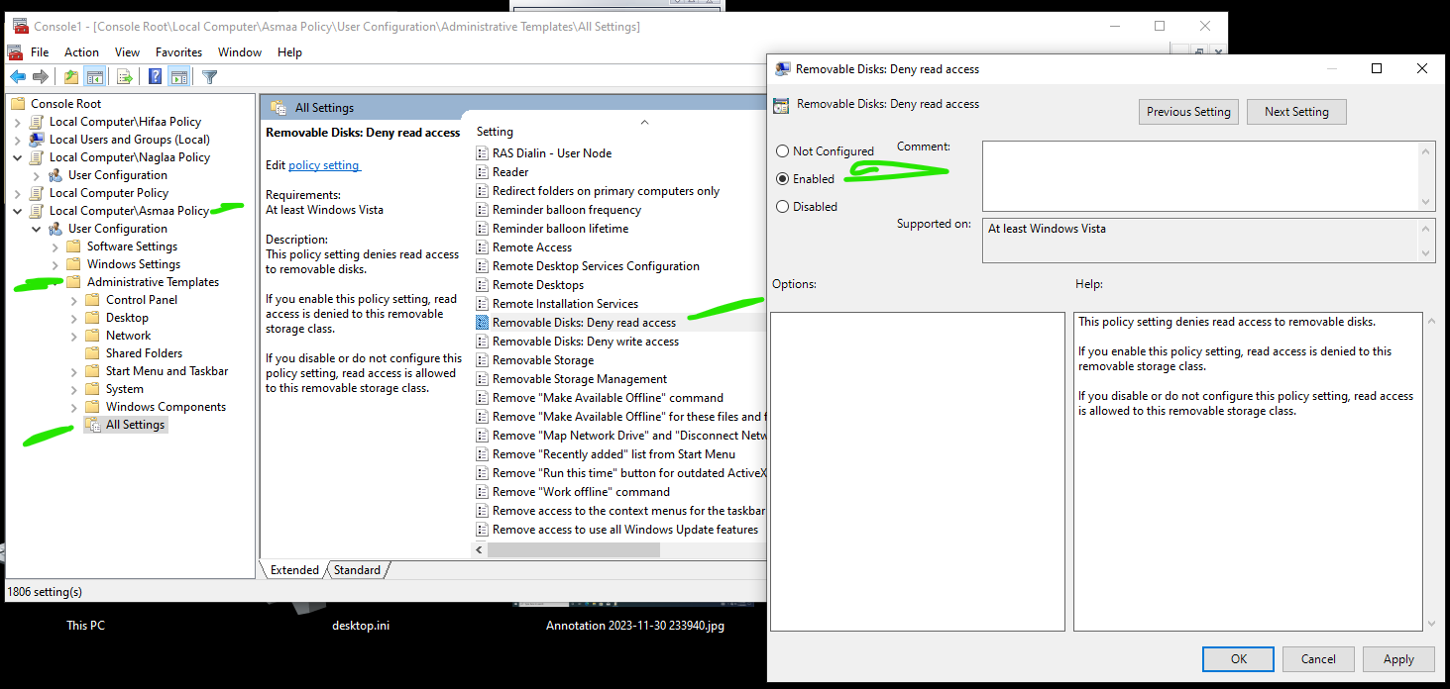

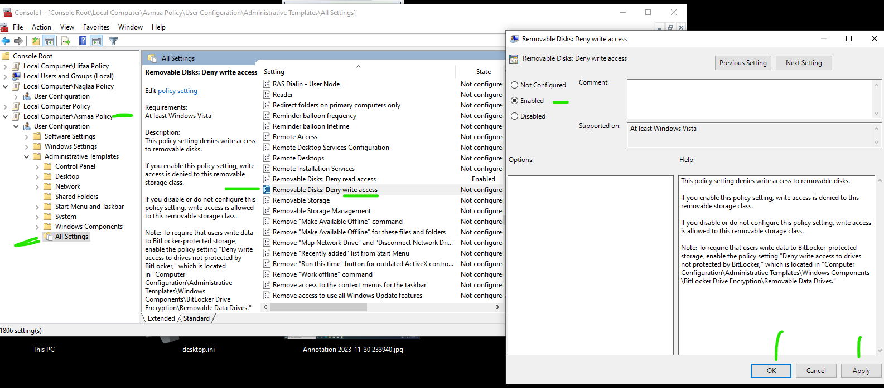

* Force all users to use specific wallpaper except Hifaa

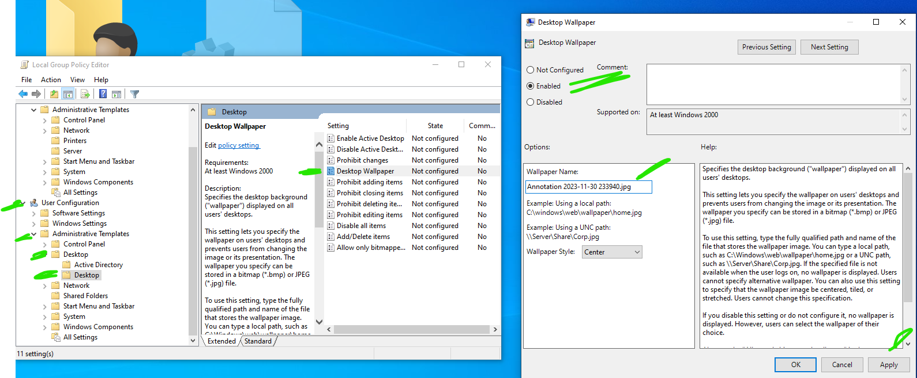

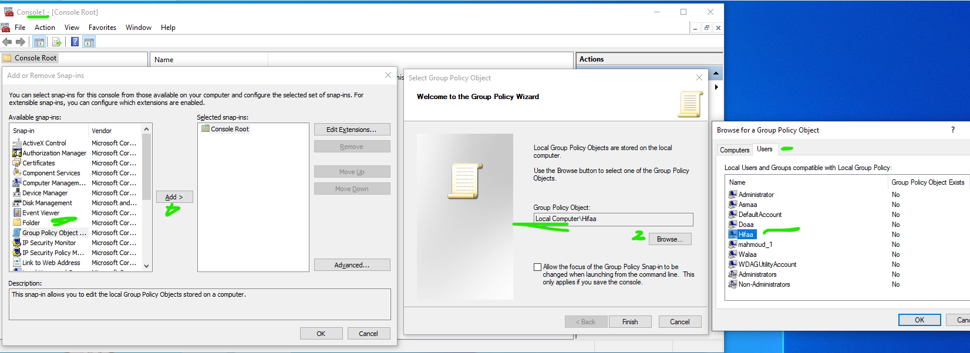

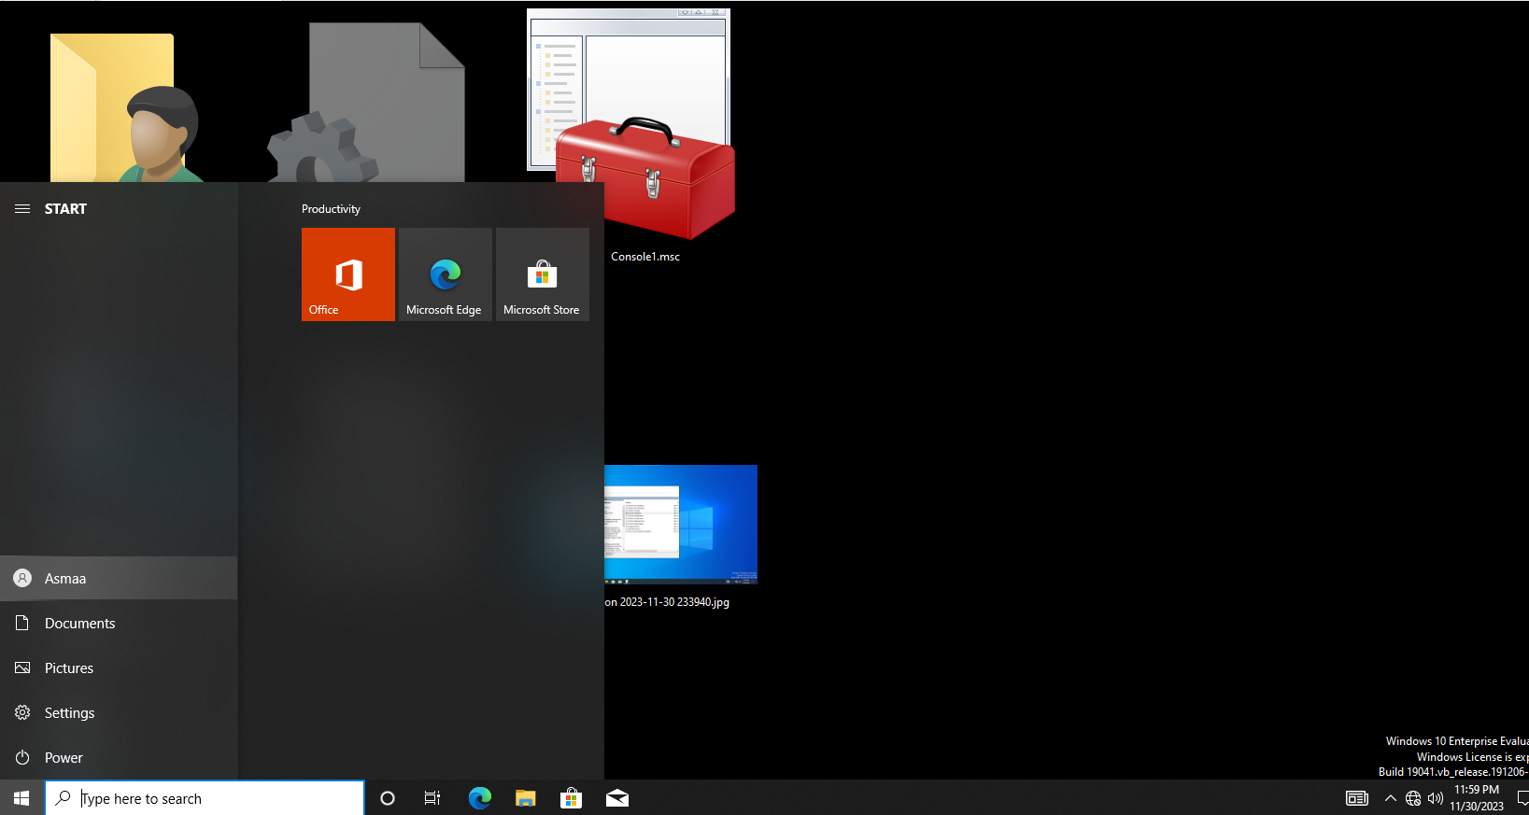



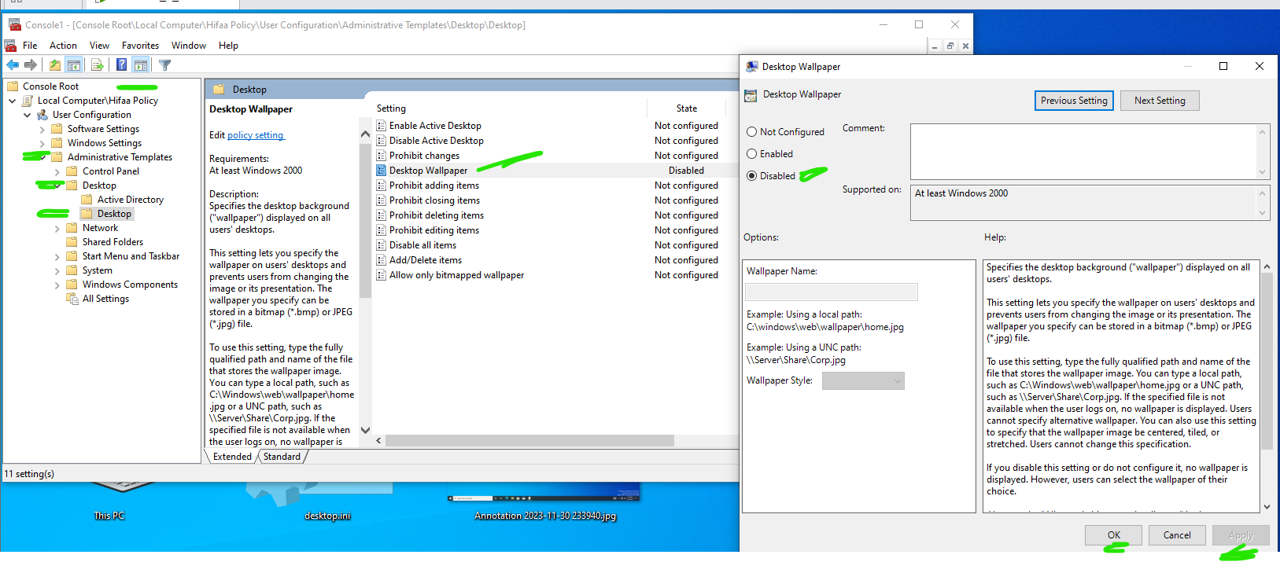

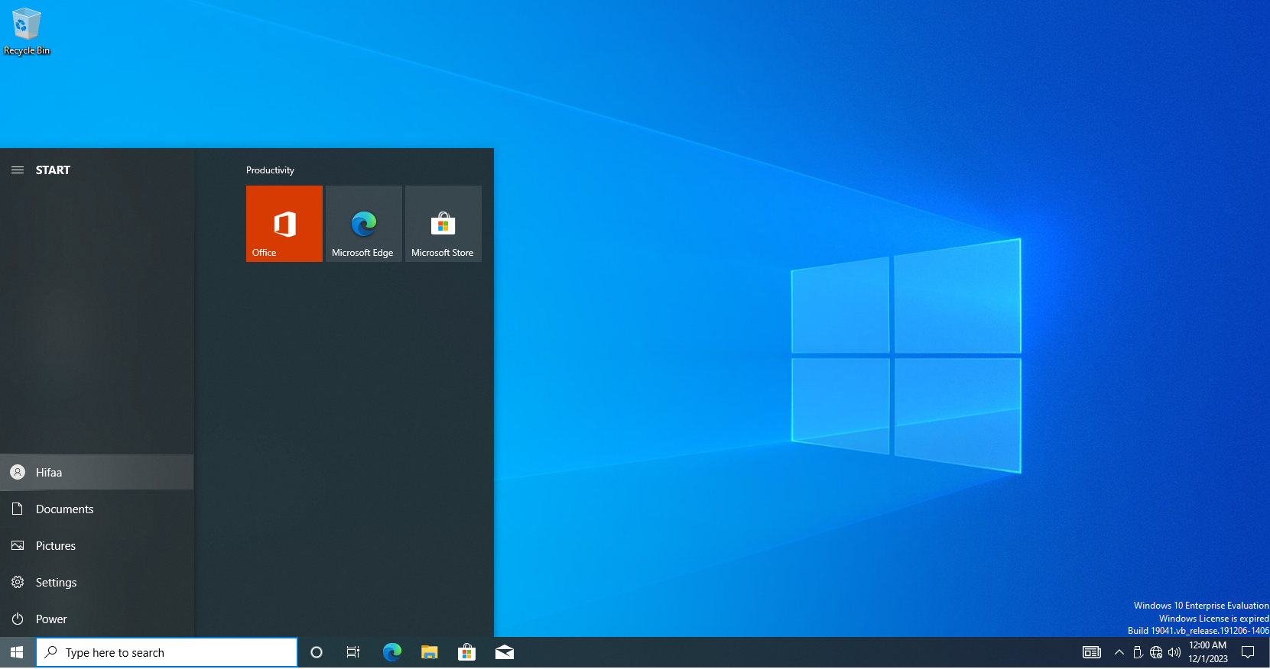



* Remove clock for user Naglaa

